Design Specification

Game Summary

Objective(s)

Player controlled tank vs AI controlled enemy tanks which move through a maze towards the player’s base, located in the centre. The Player must shoot the enemy tanks and defend their base; otherwise, its game over!

Rules

* The player cannot win the game per say, however the aim is for the player to defeat incremental waves of enemies, and setting new high-scores.
* The player loses if they die or if their base is destroyed.

Game play

The player has control of a tank, which they use to defend their base from the enemies (AI controlled). The player and the base have health stats. If either of them reach zero, the player loses. The enemies spawn in incremental waves: The first wave spawns five enemies, and increments by 3n for the first 10 rounds, then 2n from there, where n is the wave number if the player successfully destroys all of them. The priority of the enemy is the player’s base, so they will primarily move towards the base unless the player is within a certain range, and they are still far from the base, in which case they will shoot the player.

Research

The research for references only comprised of three games: Battle City, 1985 for NES, Tank Trouble Online in 2007 and Tanks for Nintendo Wii in 2006. These three games provided sufficient material to start brainstorming for ideas.

The game Battle City provided the most material for brainstorming. It was a simple one or two player game, where the aim was to defend your base of the enemy AI. The enemy AI itself was way too easy, so we decided to upgrade it using A* for the AI with priority on shooting the player’s base over the player. Tank Trouble and Tanks Wii gave us idea for extra implementations we could do to flesh out the game.

We used quick brain storming on paper (Fig.1), to get ideas to implement as core game objectives

Screen/Level Map

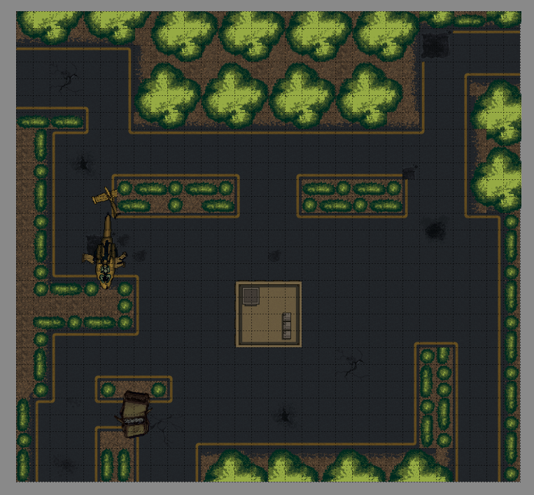Map Size: 32 x 32 tiles.

1. Helicopter: Is a barrier which the enemy or the player can’t go through but can shoot through.
2. Humvee: Is a barrier which the enemy or the player can’t go through but can shoot through.
3. Base: Player’s base. It has a health pool of 100, but takes less damage than the player. If it reaches zero, the player loses.
4. S1, S2, S3, S4, S5: Spawn points for the enemies. They are selected randomly each time a new wave of enemies spawn.
5. B1, B2, B3: Just like the helicopter and Humvee, this are barriers which the enemy and the player can’t go through but shoot.

Implementation Specification

Where appropriate, provide clear explanations of the data structures and code used within game. These should include:

* Functions/Objects

main.js



Boot.js



Preload.js



MainMenu.js

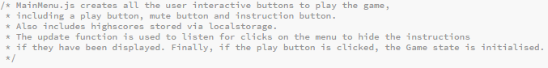

Lose.js



Game.js

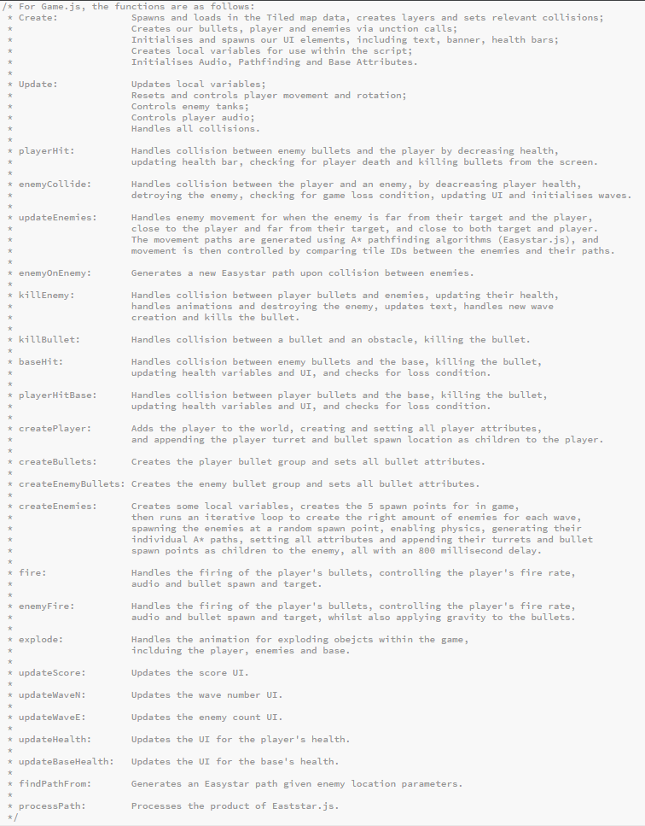

* Code Structure

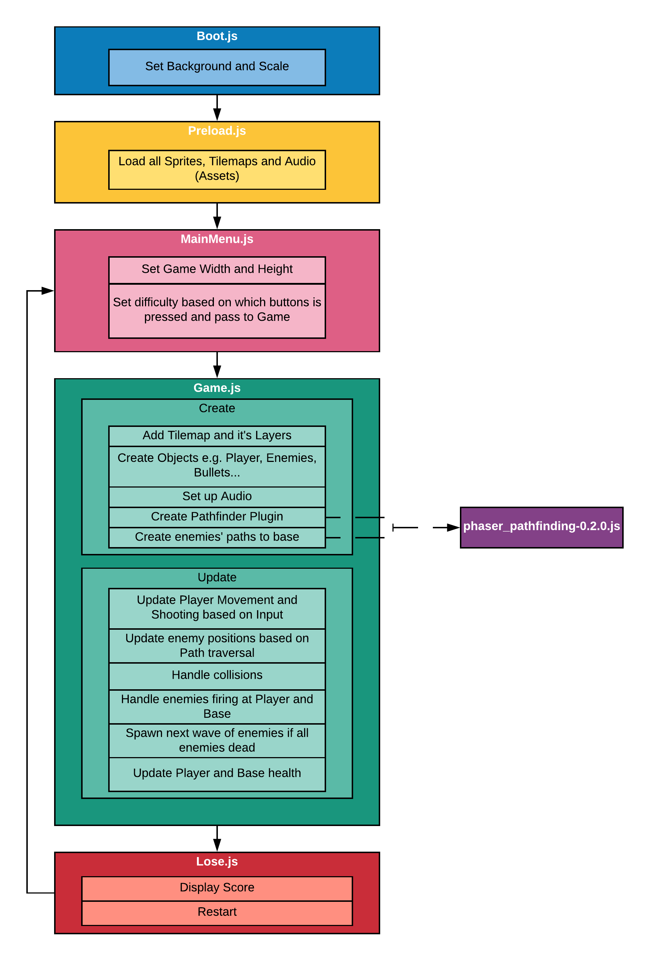

* Assets**:**

Obtained: Vehicles, Projectiles, Environment, Animations, health bar, audio

Produced: Logo, main screen, lose screen, menu buttons, base health bar, audio (modified), Level, banner.

* Implementation Evaluation

Provide a summary of the strengths and weaknesses of the technologies (platforms/frameworks etc) that you used to implement your game.

Our game has a strong code structure, and runs an effective game loop, whilst making efficient use of assets, and having a good state management system. We also have implemented A* path finding which generates based off the enemy locations across their walkable area on the map. We have 2 enemy types, where the enemy becomes stronger after wave 10, and have local storage variables for holding the player’s high-score for the next game. We’ve used good quality assets, some obtained from royalty free sources, others modified (e.g. audio, enemy and player sprites, level creation) or created from scratch by ourselves, particularly the UI. Our best strength as a team has been our religious use of github for code and asset management between the team, being a lifesaver in some cases for fixes new errors and accessing our files anywhere. The repository can be found at: [www.github.com/SebRabau/Tankk/](http://www.github.com/SebRabau/Tankk/)

The game does have a few weaknesses, for instance the most annoying one is the newest update from Google Chrome which blocks autoplay sounds from tabs by default. We have however provided a fix for this in the README.md file. There have been a few bugs as well that have been spotted in the game. Many have been squashed, however the known remaining ones we have been unable to fix thus far are as follows:

* + If you are too close the base, and the spawn point for the player’s bullets is overlapping the base, the player is able to shoot through the base. Occasionally player bullets from across the map can also pass through the base.
  + Occasionally the enemies can spawn on top of each other, which can throw an error in pathfinding, crashing the game, however we have implemented some fixes which has made this a very rare occurrence. This can also happen in the enemies bump into each other, and are pushed off the walkable area of the map, preventing them from generating a new path, either crashing the game or allowing them to walk off into infinity and beyond. This however has been patched as best as possible.
  + Collision between the enemies and the unwalkable area has had to be disabled as the enemies would find themselves getting stuck with the boundaries as whilst easystar was generating a good path for the enemy, the enemy asset would overlay the unwalkable obstacles, getting stuck. This is a frustrating error that we have yet to find a fix for.
* References**: (also found in README.md)**

# Tankk

Phaser tank game in 3-man group with Leandro Santos, Joashua Ruane and Myself

# **IMPORTANT UPDATE TO CHROME SOUNDS**

https://developers.google.com/web/updates/2017/09/autoplay-policy-changes

Recently a new update has been released for chrome whereby autoplaying will automatically be muted. In order to un-mute sounds in chrome, type chrome://flags/#autoplay-policy in the chrome url bar, and change the value of the Chrome flag "Autoplay Policy" to "No user gesture is required" to disable this feature.

### InGame Assets

* Tank Assets - https://graphicriver.net/item/tds-pixel-art-game-assets/20651122

* Environment Assets - https://graphicriver.net/item/tds-pixel-art-game-assets/20651122

* Animations - https://graphicriver.net/item/tds-pixel-art-game-assets/20651122

* Bullet Asset - https://opengameart.org/content/bullet-collection-1-m484

### Scripts References

* Eastar.js - https://github.com/appsbu-de/phaser_plugin_pathfinding

### UI

* Player Health Bar - https://opengameart.org/content/health-bar

* Tank On the Logo: https://www.vectorstock.com/royalty-free-vector/icon-military-tank-silhouette-vector-16392181

* Wings for base health - https://www.freepik.com/free-vector/wing-logos-in-flat-design_1171281.htm#term=wings&page=1&position=4

* Logo Font - https://fonts2u.com/after-attack.font

### Audio:

* Player explosion - https://www.zapsplat.com/music/car-explosion-bomb-debris/

* Enemy explosion - https://www.zapsplat.com/music/explosion-metal-debris/

* Dirt sound - https://www.zapsplat.com/music/car-wheels-roll-with-engine-off-on-dirt-track-short-distance-then-stop-2/

* Engine sound - https://www.zapsplat.com/music/car-1950-mercury-255-ci-flathead-engine-idle/

* Tank fire sound - https://www.zapsplat.com/music/grenade-explosion-debris-blast/

* Enemy fire sound - https://www.zapsplat.com/music/gun-pistol-single-shot-silenced-walther-pp7/

* Menu Music - "I Can Feel it Coming" Kevin MacLeod (incompetech.com) Licensed under Creative Commons: By Attribution 3.0 License http://creativecommons.org/licenses/by/3.0/

## Licenses:

LICENSE CERTIFICATE : Envato Market Item

==============================================

This document certifies the purchase of:

ONE REGULAR LICENSE

as defined in the standard terms and conditions on Envato Market.

Licensor's Author Username:

craftpix_net

Licensee:

Leandro Santos

Item Title:

TDS Pixel Art Game Assets

Item URL:

https://graphicriver.net/item/tds-pixel-art-game-assets/20651122

Item ID:

20651122

Item Purchase Code:

cf8b4cfc-f609-4596-baab-cefbe50cf585

Purchase Date:

2018-04-17 13:26:57 UTC

For any queries related to this document or license please contact Help Team via https://help.author.envato.com

Envato Pty. Ltd. (ABN 11 119 159 741)

PO Box 16122, Collins Street West, VIC 8007, Australia

==== THIS IS NOT A TAX RECEIPT OR INVOICE ====

* Appendix 1

Game Concept Presentation provided in the documentation folder.

* Appendix 2

Any further design sketches, background information, research that you wish to submit.

w

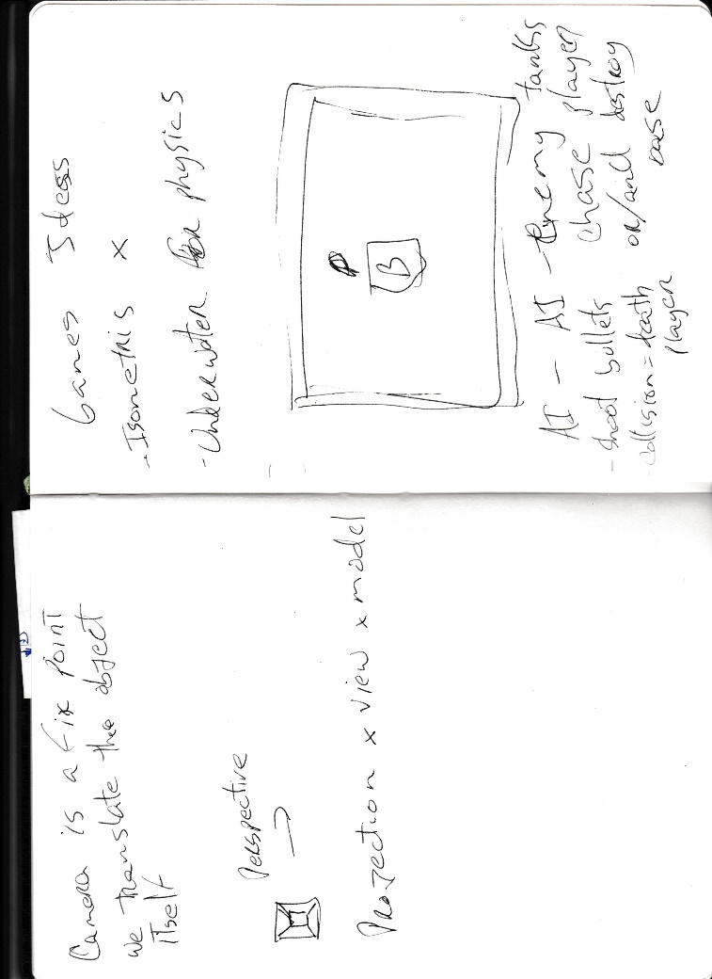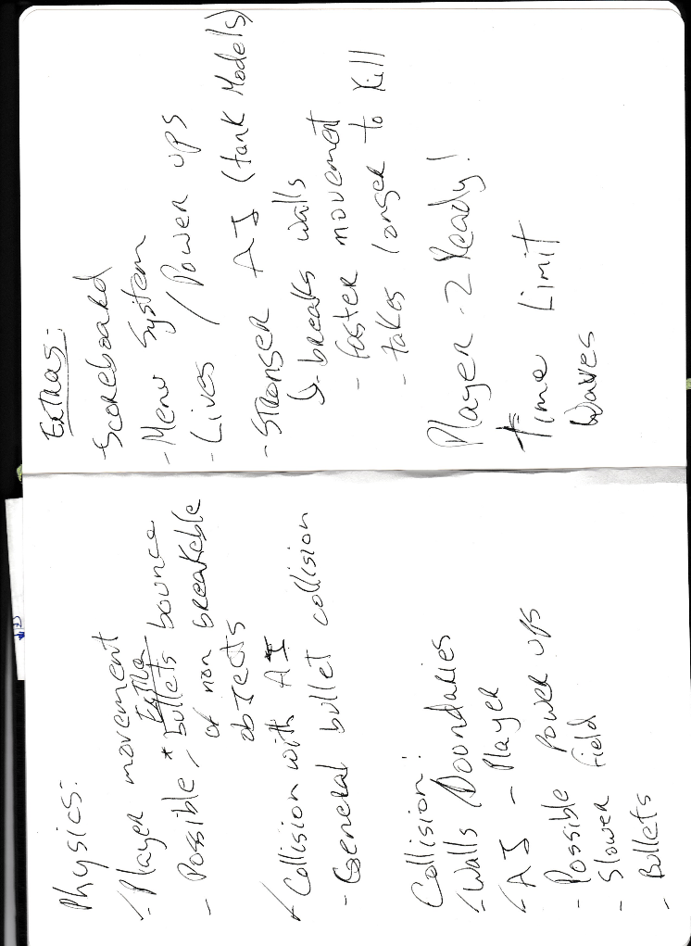

Fig.1: Brainstorming

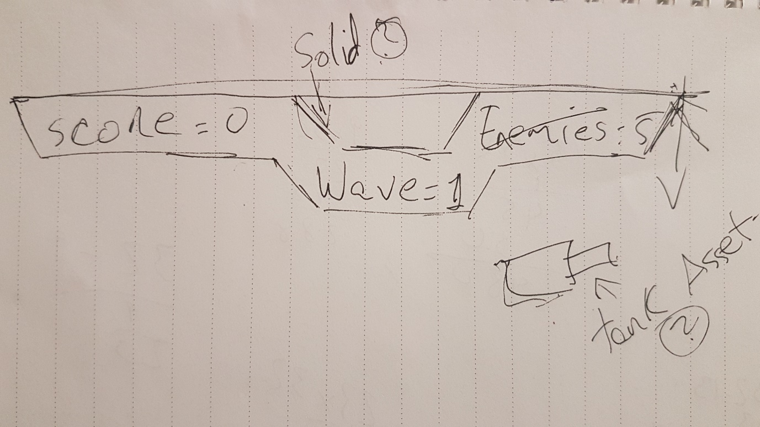

Fig.2: Banner sketch